Chapter 3, Solution 12

There are two unknown nodes, as shown in the circuit below.
20 Ω
+
_
20 Ω
10 Ω
40 V
4 I_{x}
10 Ω
V_{o}
V₁

I_{x}

At node 1,
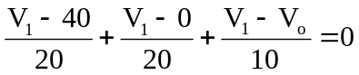or
(0.05+0.05+.1)V₁ – 0.1V_{o} = 0.2V₁ – 0.1V_{o} = 2 (1)

At node o,
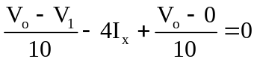 and I_{x} = V₁/20
–0.1V₁ – 0.2V₁ + 0.2V_{o} = –0.3V₁ + 0.2V_{o} = 0 or (2)

V₁ = (2/3)V_{o} (3)

Substituting (3) into (1),

0.2(2/3)V_{o} – 0.1V_{o} = 0.03333V_{o} = 2 or

V_{o} = 60 V.

